

Product Specification
Customer: _____________________________
Model Name: _____ZT020Q01
Date: _____________________________
Version: _____________________________

■ Preliminary Specification
□ Final Specification

For Customer’s Acceptance
Approved by | Comment

Approved by | Reviewed by | Prepared by

Table of Contents
1 Record of Revision 3
2 General Specifications 4
3 Input/Output Terminals 5
4 Absolute Maximum Ratings 6
5 Electrical Characteristics 6
6 Interface Timing 6
7 Optical Characteristics 10
8 Environmental / Reliability Tests 13
9 Mechanical Drawing 19
10 Packing 20
11 Precautions For Use of LCD modules 21

1. Record of Revision
Rev | Issued Date | Description | Editor
1.0 | 2023/05/04 | First Release. | Shengsen wang

2．General Specifications
Feature |  | Spec
Characteristics | Size | 2.0inch
Characteristics | Resolution | 240(horizontal)*320(Vertical)
Characteristics | Interface | 4-Line SPI
Characteristics | Connect type | ZIF
Characteristics | Color Depth | TBD
Characteristics | Technology type | a-Si
Characteristics | Pixel pitch (mm) | 0.0425*3*0.1275
Characteristics | Pixel Configuration | R.G.B. Vertical Stripe
Characteristics | Display Mode | Normally Black
Characteristics | Driver IC | ST7789V2
Characteristics | Surface Treatment | -
Characteristics | Viewing Direction | ALL
Mechanical | LCM (W x H x D) (mm) | 34.98*50.57*2.4
Mechanical | Active Area(mm) | 30.6*40.8
Mechanical | With /Without TSP | Without
Mechanical | Weight (g) | TBD
Mechanical | LED Numbers | 3 LEDs

Note 1: Viewing direction is follow the data which measured by optics equipment.
Note 2: Requirements on Environmental Protection: RoHS
Note 3: LCM weight tolerance: +/- 5%

3. Input/Output Terminals

PIN NO. | Symbol | Description
1 | NC | No connection
2 | RESET | Reset signal input terminal
3 | CS | Chip selection pin
4 | GND | Ground
5 | SDA | serial data Input/Output
6 | SCL | Serial lock.
7 | VDDI0 | Power supply for I/O system
8 | VDD | Power supply for analog,Digital system and booster circuit
9 | GND | Ground
10 | LEDK | LED backlight cathode
11 | LEDA | LED backlight anode
12 | DXC | Display data/command selection pin in parallel interface;

4．Absolute Maximum Ratings
4.1 Driving TFT LCD Panel
Item | Symbol | MIN | MAX | Unit | Remark
Supply Voltage | V_{DD} | -0.3 | 5 | V
Operating Temperature | T_{OPR} | -20 | 70 | ℃
Storage Temperature | T_{STG} | -30 | 80 | ℃

5. Electrical Characteristics

Item | Symbol | MIN | TYP | MAX | Unit | Remark
Forward Current | I_{F} | - | 60 | - | mA
Forward Voltage | V_{F} | - | 3.2 | - | V
Backlight Power consumption | W_{BL} | - | 0.192 | - | W
Note 1: Each LED : IF =20 mA, VF =3.2V.
Note 2: Optical performance should be evaluated at Ta=25℃ only.
Note 3: If LED is driven by high current, high ambient temperature & humidity condition. The life
time of LED will be reduced.Operating life means brightness goes down to 50% initial brightness.
Typical operating life time is estimated data.

6．Interface Timing
6.1 AC charateristics
Serial interface characteristics(4-line serial)
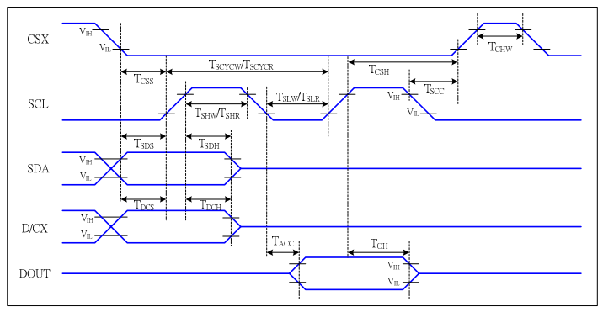
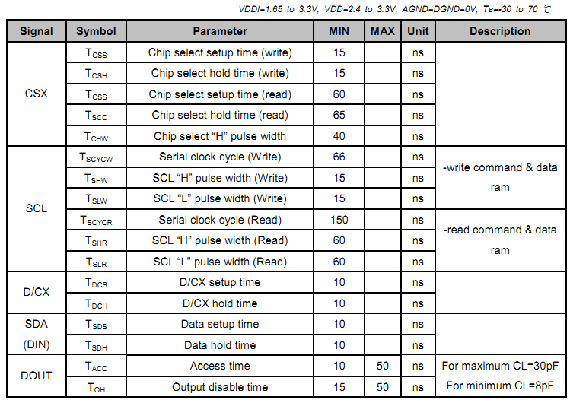
4-Line serial interface characteristics

6.2 Power Supply Configuration
IOVCC and VCI can be applied or powered down in any order. During the Power Off sequence, if the
LCD is in the Sleep Out mode, VCI and IOVCC must be powered down with a minimum of 120msec. If the LCD is in the Sleep In mode, VCI and IOVCC can be powered down with a minimum of 0msec
after the RESX has been released. CSX can be applied at any time or can be permanently grounded. RESX has high priority over CSX. Notes:
1. There will be no damage to the ILI9488 if the power sequences are not met. 2. There will be no abnormal visible effects on the display panel during the Power On/Off Sequence. 3. There will be no abnormal visible effects on the display between the end of the Power On Sequence
and before receiving the Sleep Out command, and also between receiving the Sleep In command and
the Power Off Sequence. 4. If the RESX line is not steadily held by the host during the Power On Sequence as defined in
Sections 11.1 and 11.2, then it will be necessary to apply the Hardware Reset (RESX) after the
completion of the Host Power On Sequence to ensure correct operations. Otherwise, all the functions
are not guaranteed. 5. When the power is turned on, the climb period timing(Trise) must be greater than 10us. 6. Keep data pins DB[23:0] at low level, when VCI or IOVCC comes later

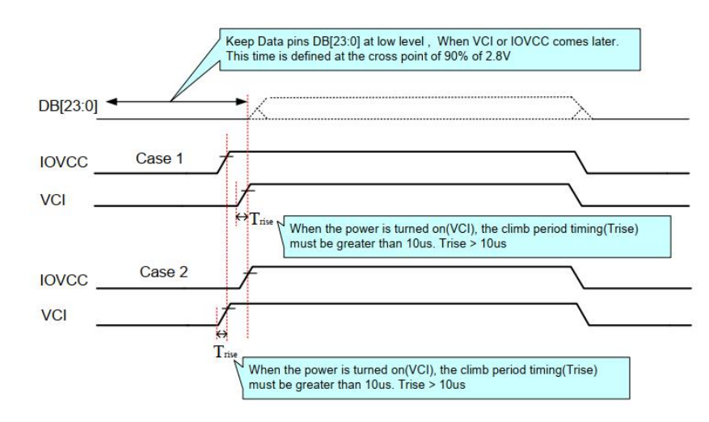
Case 1 – RESX Line is Held High or Unstable by Host at Power ON
If the RESX line is held High or unstable by the host during Power On, then Hardware Reset must be
applied after both VCI and IOVCC have been applied. Otherwise, the correct functionality is not
guaranteed. There is no timing restriction upon this hardware reset
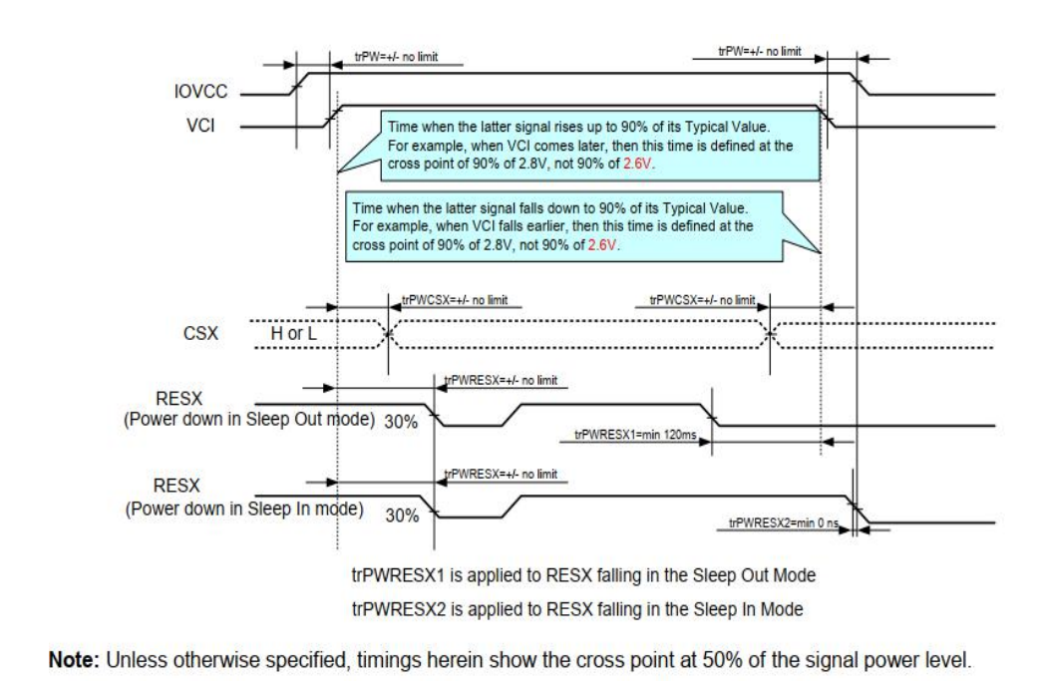
Case 2 – RESX Line is Held Low by Host at Power ON
If the RESX line is held Low (and stable) by the host during Power On, then the RESX must be held
low for a minimum of 10μsec after both VCI and IOVCC have been applied
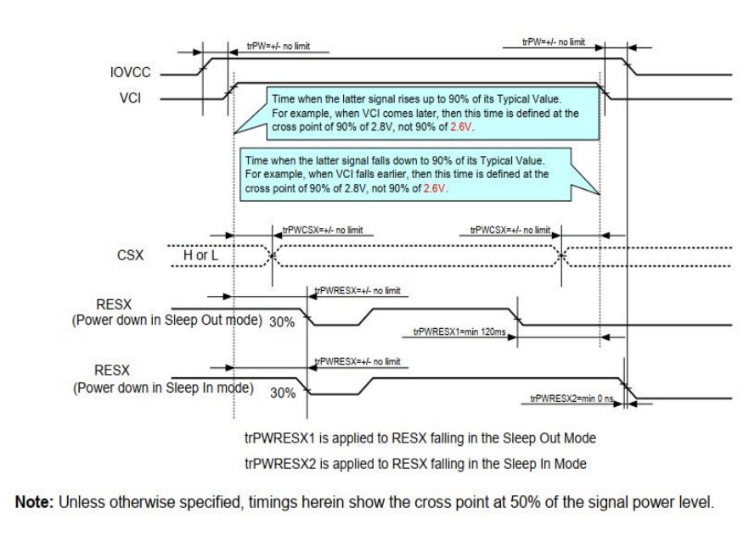
Uncontrolled Power Off
The Uncontrolled Power Off means the situation when a battery is removed without the controlled
power off sequence. There will not be any damages on the display module, or the display module will
not cause any damages on the host or lines of the interface. At an uncontrolled power off event, the
ILI9488 will force the display to become blank and will not cause any abnormal visible effects within
1 second on the display and remains blank until “Power On Sequence” powers it up.

7. Optical Characteristics
Items |  | Symbol | Condition | Min. | Typ. |  | Max. | Unit | Remark
Viewing angles |  | θ_{T} | Center  CR≥10 | - | 80 |  | - | Degree. | Note2
 |  | θ_{B} | Center  CR≥10 | - | 80 |  | - | Degree. | Note2
 |  | θ_{L} | Center  CR≥10 | - | 80 |  | - | Degree. | Note2
 |  | θ_{R} | Center  CR≥10 | - | 80 |  | - | Degree. | Note2
Contrast Ratio |  | CR | Θ =0 | -- | 500 |  | - | - | Note1, Note3
Response Time |  | T_{ON}  ₊  T_{OFF} | 25°C | - |  | 30 | 35 | ms | Note1, Note4
Chromaticity | White | X_{W} | Backlight  is on | 0.280 | 0.300 |  | 0.320 | - | Note1, Note5
Chromaticity | White | Y_{W} | Backlight  is on | 0.320 | 0.340 |  | 0.360 | - | Note1, Note5
Chromaticity | Red | X_{R} | Backlight  is on | 0.617 | 0.655 |  | 0.657 | - | Note1, Note5
Chromaticity | Red | Y_{R} | Backlight  is on | 0.318 | 0.317 |  | 0.358 | - | Note1, Note5
Chromaticity | Green | X_{G} | Backlight  is on | 0.269 | 0.260 |  | 0.309 | - | Note1, Note5
Chromaticity | Green | Y_{G} | Backlight  is on | 0.569 | 0.571 |  | 0.619 | - | Note1, Note5
Chromaticity | Blue | X_{B} | Backlight  is on | 0.116 | 0.144 |  | 0.156 | - | Note1, Note5
Chromaticity | Blue | Y_{B} | Backlight  is on | 0.064 | 0.074 |  | 0.163 | - | Note1, Note5
Luminance |  | L |  |  | 300 |  |  | Cd/m2 | Note1, Note7

Test Conditions:
1. IF= 20mA(one channel),the ambient temperature is 25.
2. The test systems refer to Note 1 and Note 2.
Note 1:Definition of optical measurement system.
The optical characteristics should be measured in dark room. After 5 minutes operation, the optical
properties are measured at the center point of the LCD screen. All input terminals LCD panel must
be ground when measuring the center area of the panel.

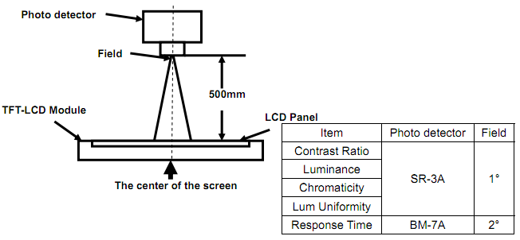
Note 2: Definition of viewing angle range and measurement system.
Viewing angle is measured at the center point of the LCD by CONOSCOPE (ergo-80).
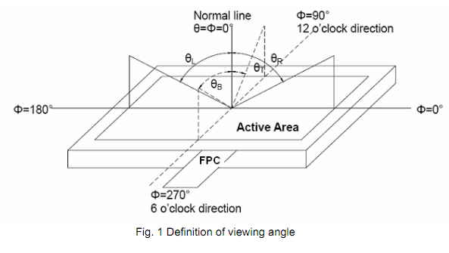
Note 3: Definition of contrast ratio
Note 4: Definition of Response time
The response time is defined as the LCD optical switching time interval between “White” state and
“Black” state. Rise time (TON) is the time between photo detector output intensity changed from
90% to 10%. And fall time (TOFF) is the time between photo detector output intensity changed from
10% to 90%.
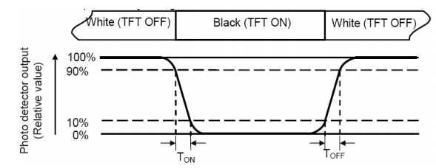
Note 5: Definition of color chromaticity (CIE1931)
Color coordinates measured at center point of LCD.
Note 6: Definition of Luminance Uniformity
Active area is divided into 9 measuring areas (Refer Fig. 2). Every measuring point is placed at the
center of each measuring area.
Luminance Uniformity(U) = Lmin/ Lmax
L-------Active area length W----- Active area width
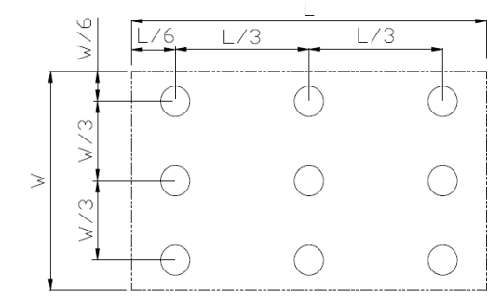
Fig. 2 Definition of uniformity
Lmax: The measured maximum luminance of all measurement position.
Lmin: The measured minimum luminance of all measurement position.
Note 7: Definition of Luminance :
Measure the luminance of white state at center point.

8. Environmental / Reliability Tests
No | Test Item | Condition | Remarks
1 | High Temperature  Opeartion | Ts= +70℃, 240hrs | Note 1  IEC60068-2-2, GB2423. 2-89
2 | Low Temperature  Opeartion | Ta= -20℃, 240hrs | Note 2 IEC60068-2-1  GB2423.1-89
3 | High Temperature  Storage | Ta= +80℃, 240hrs | IEC60068-2-2  GB2423. 2-89
4 | Low Temperature  Storage | Ta= -30℃, 240hrs | IEC60068-2-1  GB/T2423.1-89
5 | High Temperature &  Humidity Storage | Ta= +60℃, 90% RH max, 160 hours | IEC60068-2-3  GB/T2423.3-2006
6 | Thermal Shock  (Non-operation) | -30℃ 30 min ~ +80℃ 30 min  Change time: 5min, 30 Cycle | Start with cold temperature,end with high temperature  IEC60068-2-14, GB2423.22-87
7 | Electro Static Discharge  (Opeartion) | C=150pF, R=330 Ω, 5 points/panel  Air:±8KV, 5 times; Contact: ±4KV, 5 times; (Environment: 15℃ ~  35℃, 30% ~ 60%, 86Kpa ~ 106Kpa) | IEC61000-4-2  GB/T17626.2-1998
8 | Vibration (Non-operation) | Frequency range: 10~55Hz, Stroke:  1.mm Sweep: 10Hz~55Hz~10Hz  2 hours for each direction of X .Y. Z.  (package condition) | IEC60068-2-6  GB/T2423.5-1995
9 | Shock (Non-operation) | 60G 6ms, ± X, ±Y , ± Z  3 times for each direction | IEC60068-2-27  GB/T2423.5-1995
10 | Package Drop Test | Height: 80 cm, 1 corner, 3 edges,  6 surfaces | IEC60068-2-32  GB/T2423.8-1995

Note: 1. T_{S} is the temperature of panel’s surface.
2. Ta is the ambient temperature of sample.

9．Mechanical Drawing
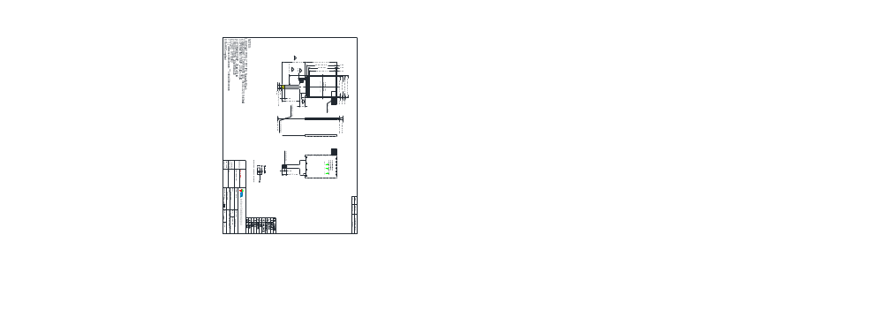

10． Packing
Packing Method
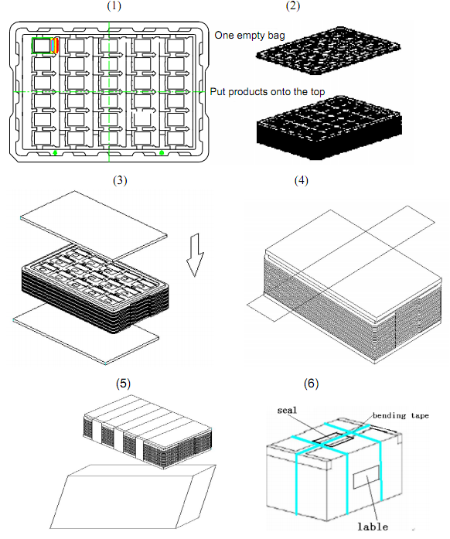
1. Put module into tray cavity:
2. Tray stacking
3. Put 1 cardboard under the tray stack and 1 cardboard above:
4. Fix the cardboard to the tray stack with adhesive tape:
5. Put the tray stack into carton.
6. Carton sealing with adhesive tape.

11.Precautions For Use of LCD modules
11.1 Handling Precautions
11.1.1. The display panel is made of glass. Do not subject it to a mechanical shock by dropping it from a high place, etc.
11.1.2. If the display panel is damaged and the liquid crystal substance inside it leaks out, be sure not to get any in your mouth, if the substance comes into contact with your skin or clothes, promptly wash it off using soap and water.
11.1.3. Do not apply excessive force to the display surface or the adjoining areas since this may cause the color tone to vary.
11.1.4. The polarizer covering the display surface of the LCD module is soft and easily scratched. Handle this polarizer carefully.
11.1.5. If the display surface is contaminated, breathe on the surface and gently wipe it with a soft dry cloth. If still not completely clear, moisten cloth with one of the following solvents:
－ Isopropyl alcohol
－ Ethyl alcohol
Solvents other than those mentioned above may damage the polarizer. Especially, do not use the following:
－ Water
－ Ketone
－ Aromatic solvents
11.1.6. Do not attempt to disassemble the LCD Module.
11.1.7. If the logic circuit power is off, do not apply the input signals.
11.1.8. To prevent destruction of the elements by static electricity, be careful to maintain an optimum work environment.
11.1.8.1. Be sure to ground the body when handling the LCD Modules.
11.1.8.2. Tools required for assembly, such as soldering irons, must be properly ground.
11.1.8.3. To reduce the amount of static electricity generated, do not conduct assembly and other work under dry conditions.
11.1.8.4. The LCD Module is coated with a film to protect the display surface. Be care when peeling off this protective film since static electricity may be generated.
11.2 Storage Precautions
11.2.1. When storing the LCD modules, avoid exposure to direct sunlight or to the light of fluorescent lamps.
11.2.2. The LCD modules should be stored under the storage temperature range If the LCD modules will be stored for a long time, the recommend condition is:
Temperature : 0℃ ～ 40℃ Relatively humidity: ≤80%
11.2.3. The LCD modules should be stored in the room without acid, alkali and harmful gas.
11.3 Transportation Precautions
The LCD modules should be no falling and violent shocking during transportation, and also should avoid excessive press, water, damp and sunshine.

